Program No:01
#include <iostream>
using namespace std;

int main()
{
int R, C;
cin >> R >> C;

int arr[100][100];
int sum = 0;

for(int i = 0; i < R; i++)
{
for(int j = 0; j < C; j++)
{
cin >> arr[i][j];
}
}

for(int i = 0; i < R; i++)
{
for(int j = 0; j < C; j++)
{
sum += arr[i][j];
}
}

cout << sum;

return 0;
}
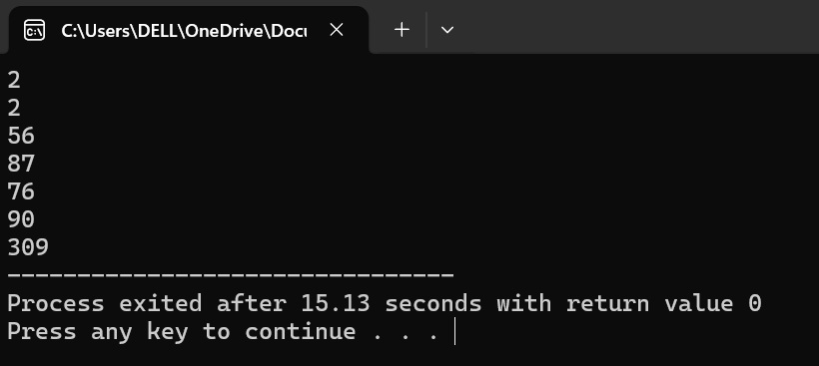
Program no:02
#include <iostream>
using namespace std;

int main() {
int R, C;
cin >> R >> C;

int arr[100][100];

for (int i = 0; i < R; i++) {
for (int j = 0; j < C; j++) {
cin >> arr[i][j];
}
}

int result = arr[0][0];

for (int i = 0; i < R; i++) {
for (int j = 0; j < C; j++) {
if (i == 0 && j == 0)
continue;
result -= arr[i][j];
}
}

cout << result

return 0;
}
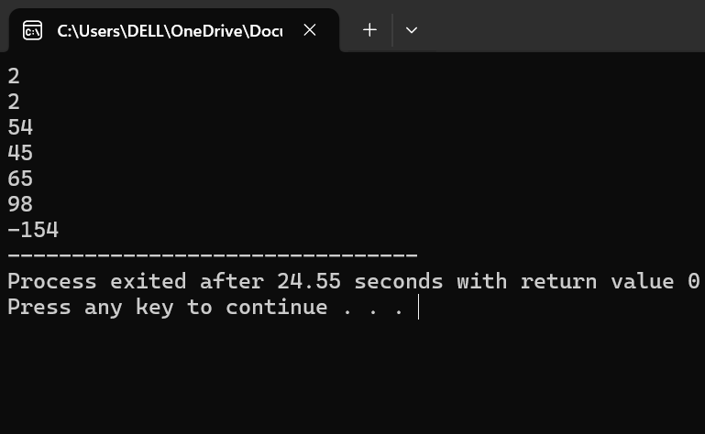
Program no:03
#include <iostream>
using namespace std;

double calculateArea(double side) {
return side * side;
}

double calculateArea(double length, double width) {
return length * width;
}

int main() {
double side, length, width;

cin >> side;
cin >> length >> width;

cout << "Area of Square: " << calculateArea(side) << endl;
cout << "Area of Rectangle: " << calculateArea(length, width);

return 0;
}
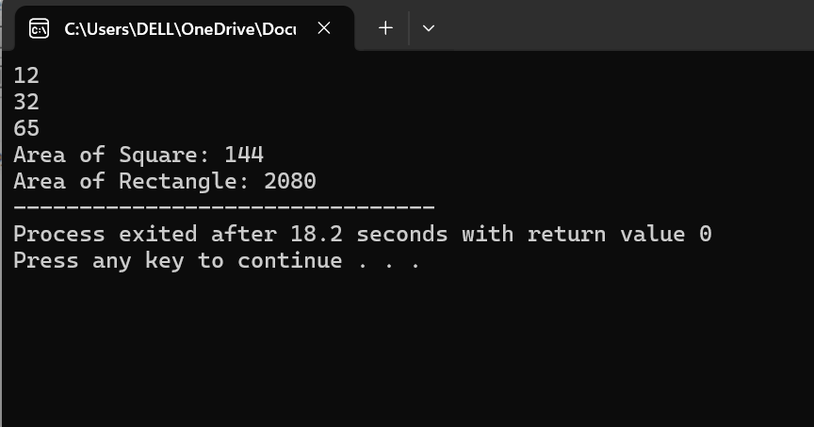
Program no:04
#include <iostream>
using namespace std;

double getBowlingAverage(int runsConceded, int wicketsTaken) {
if (wicketsTaken == 0) {
return 0.0;
}

return (double)runsConceded / wicketsTaken;
}

int main() {
int runsConceded, wicketsTaken;

cin >> runsConceded >> wicketsTaken;

cout << "Bowling Average: "
<< getBowlingAverage(runsConceded, wicketsTaken);

return 0;
}
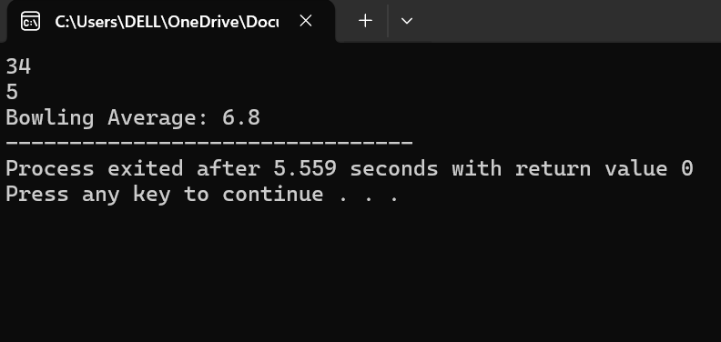
Program No:05
#include <iostream>
using namespace std;

void printVertical(char word[], int size) {
for (int i = 0; i < size; i++) {
cout << word[i] << endl;
}
}

int main() {
char word[100];
cin >> word;

int size = 0;
while (word[size] != '\0') {
size++;
}

printVertical(word, size);

return 0;
}
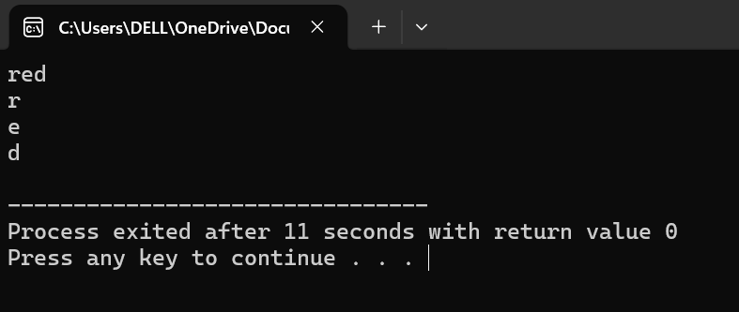
Program no:06
#include <iostream>
using namespace std;
void reverseWord(char word[], int size) {
for (int i = 0; i < size / 2; i++) {
char temp = word[i];
word[i] = word[size - 1 - i];
word[size - 1 - i] = temp;
}
}

int main() {
char word[100];
cin >> word;

int size = 0;
while (word[size] != '\0') {
size++;
}

reverseWord(word, size);

cout << "Reversed Word: " << word;

return 0;
}
